READWORKS.ORG

- Choose “Register”- Use personal e-mail address & a password you will remember.

- Click on “Reading Passages”

- Complete the information as follows:

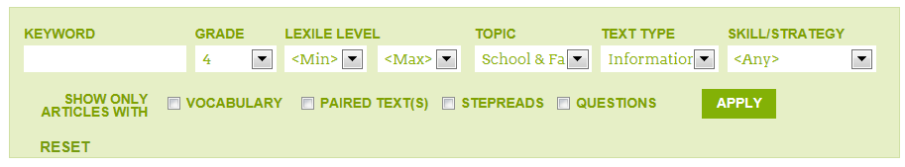
- KEYWORD- skip
- GRADE- choose low level, passages can be long
- LEXILE- skip
- DOMAIN- choose subject that interests you or choose any
- TEXT TYPE- choose informational
- SKILL/STRATEGY- choose specific skill or choose any

- CLICK “APPLY”

- You will need to “download” all passages and work. Use a pencil and paper to complete the exercises. There are answer keys attached to all work.

